1. Explain how an agile software process differs from a waterfall software process and give an advantage and a disadvantage for each

KEY DIFFERENCE

* Waterfall is a Liner Sequential Life Cycle Model whereas Agile is a continuous iteration of development and testing in the software development process.
* Agile methodology is known for its flexibility whereas Waterfall is a structured software development methodology.
* Agile follows an incremental approach whereas the Waterfall methodology is a sequential design process.
* Agile performs testing concurrently with software development whereas in Waterfall methodology testing comes after the “Build” phase.
* Agile allows changes in project development requirement whereas Waterfall has no scope of changing the requirements once the project development starts.

Advantages of Waterfall Model:

* It is one the easiest model to manage. Because of its nature, each phase has specific deliverables and a review process.
* It works well for smaller size projects where requirements are easily understandable.
* Faster delivery of the project
* Process and results are well documented.
* Easily adaptable method for shifting teams
* This project management methodology is beneficial to manage dependencies.

Advantages of the Agile Model:

* It is focused client process. So, it makes sure that the client is continuously involved during every stage.
* Agile teams are extremely motivated and self-organized so it likely to provide a better result from the development projects.
* Agile software development method assures that quality of the development is maintained
* The process is completely based on the incremental progress. Therefore, the client and team know exactly what is complete and what is not. This reduces risk in the development process

Disadvantages of Waterfall Model:

* It is not an ideal model for a large size project
* If the requirement is not clear at the beginning, it is a less effective method.
* Very difficult to move back to makes changes in the previous phases.
* The testing process starts once development is over. Hence, it has high chances of bugs to be found later in development where they are expensive to fix.

Disadvantages of Agile Model

* It is not useful method for small development projects.
* It requires an expert to take important decisions in the meeting.
* Cost of implementing an agile method is little more compared to other development methodologies.
* The project can easily go off track if the project manager is not clear what outcome he/she wants.

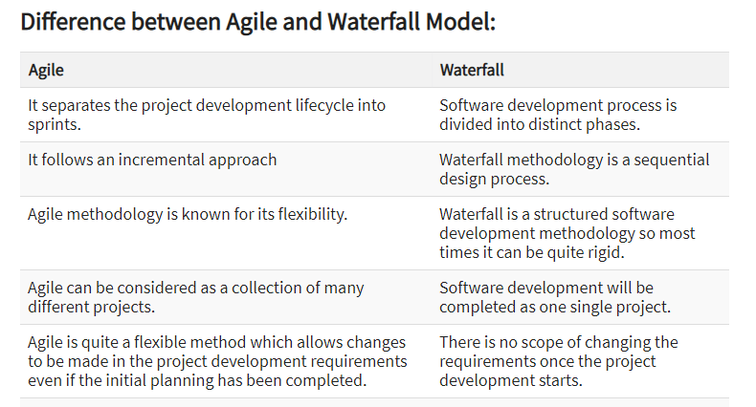

1. Why is waterfall model not suitable process model for developing a commercial gaming system? State what will be a suitable process model for such a system
2. What is RUP and how does it relate to UML
3. State and explain 4 main Object-Oriented principles in OOAD
4. Illustrate with the aid of diagrams the difference between associations with generalizations, giving examples of each